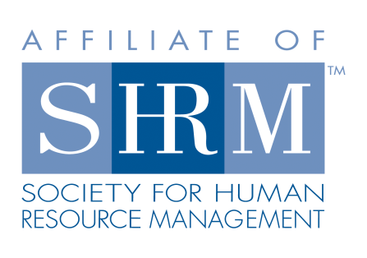

INVOICE FOR RENEWING MEMBERS

(Please return a copy of invoice with payment)

West Georgia Society for Human Resource Management

2018 Membership Dues

BENEFITS OF MEMBERSHIP:
Dues cover: Networking; monthly newsletter; conferences; informative meetings; list jobs for free; SHRM and HRCI credit approved programs; and lunch!

COST: $150 if paid by March 1st or $175 if paid after March 1st.

Name: _______________ ________________________________ Date: ______________

Company Name: _______________________________________________________________

Title:

Work Address: ________________________________________________________________

City: ________________________________ State: ___________________ Zip: ___________

Telephone: __________________________________ Fax: _____________________________

E-Mail: _______________________________________________________________________

National Member* __Y / N_ If yes, please list your National Member #: ________________

Please indicate amount enclosed:
_____ $150 Local Chapter Dues ONLY IF PAID BY MARCH 1, 2018
_____ $175 Local Chapter Dues PAID AFTER MARCH 1, 2018

Please remit payment & invoice to: PayPal by going to www.westgashrm.org
or by mail to:
West Georgia SHRM
Treasurer
P.O. Box 4475
LaGrange, GA 30241

*NATIONAL SHRM MEMBER:
(To join or renew National Membership, pay dues directly to www.shrm.org. do not submit national dues to West GA SHRM) Dues cover: 24 hours/7-days a week full access to www.shrm.org, 12 issues of HR Magazine, access to SHRM White papers at www.shrm.org; The Washington Insider (monthly updates on legal and legislative issues); monthly Mosaics (newsletter regarding diversity); access to job descriptions, HR surveys; best practices ideas; discounts on training and certification fees; and much more!
COST: $160 a year ($145.00 for new members)

